UDC 004.___
- Dremov, A. Volokyta
Method for malicious network traffic categorisation
Abstract: This paper aims to provide a solution for malicious network traffic detection and categorisation. In this paper we propose a semi-supervised GAN to train a discriminator model to categorise malicious traffic, as well as identify malicious and non-malicious traffic. The main goal is to achieve accurate categorisation of malicious traffic with few labelled examples.
Keywords: cybersecurity, network security, malicious traffic identification, machine learning, generational adversarial networks, semi-supervised learning.
Анотація: Ця стаття має на меті запропонувати рішення для виявлення та категоризації зловмисного мережевого трафіку. У цій статті ми пропонуємо напівкеровану GAN для навчання моделі дискримінатора для класифікації шкідливого трафіку, а також для ідентифікації шкідливого і нешкідливого трафіку. Основною метою є досягнення точної категоризації зловмисного трафіку з невеликою кількістю маркованих прикладів.
Ключові слова: кібербезпека, мережева безпека, ідентифікація шкідливого трафіку, машинне навчання, генеративні змагальні мережі, напівкероване навчання.
Introduction/Relevance of the research topic
Computer networks are a key part of modern digital communications. However, these networks can be susceptible to malicious network traffic and various attacks. These attacks can be categorised by specific packet information used in these attacks. As such, network intrusion and attack detection play an important part in identifying an attack and counteracting it and are a relevant area of research.
Additionally, modern machine learning methods and algorithms can be used to categorise data or objects with great precision, provided a large enough training sample. However, rapid developments in security penetration create a problem, where new penetration methods appear frequently and gathering enough packet samples for model training becomes a difficult task. Therefore, the problem of training models with few initial samples remains relevant today. A combination of these areas is the main research area of this paper.
Problem Definition
The core problem that the research focuses on is the problem of malicious traffic identification and categorisation. First part of the problem is the identification of whether or not traffic is malicious in nature. Malicious traffic is one that can be used to attack the computer network and individual devices in the network and include malware, DoS attacks, network scanning, data exfiltration, R2L etc. Second part of this problem is categorisation of malicious traffic.
Actual scientific research and issue analysis
A number of researchers have tackled the problem of network attack classification [1][2] and the effect of malicious traffic on computer networks [3]. Of particular interest to this paper is the general approach to performing a network attack described in [1], as well as classification and effects described in [2] and [3] respectively.
Additionally, research into the intrusion detection and, more importantly, an analysis of malicious traffic packet contents [4][5][6] help connect network attacks to packet contents. This allows to define features used by the machine learning algorithm.
Lastly, research in the area of applying machine learning to solve network intrusion detection problem was performed [7], where a variety of models and algorithms are used. The research describes the architecture of semi-supervised GAN networks [8].
Uninvestigated parts of general matters defining
In author’s opinion, the problem of intrusion detection using machine learning algorithms when there is insufficient data remains understudied. Additionally, proposed solutions may encounter difficulty with generalisation when being applied in different scenarios. A GAN based model could be used to achieve greater degree of generalisation.
Research objective
The purpose of this work is to research methods and models of malicious network traffic detection and categorisation with the usage of artificial intelligence models. Additionally, the purpose of the work is to create an AI model that can be used to detect classify malicious traffic with packet information.
Presentation of the main material
The dataset used in this research is NSL-KDD (https://www.kaggle.com/datasets/hassan06/nslkdd), which contains 125000 examples of network traffic packet data, as well as 22 categories based on attack type. Packets labelled “normal” indicate no attack. The features used in the classification include internet protocol used, service used, login status, login attempts, attempts to take root status, file and script creation, error rate, and other, for a total of 41 features. A total of 67000 records are labelled as non-malicious traffic and 58000 are labelled as malicious (fig. 1), (fig. 2), (fig. 3).
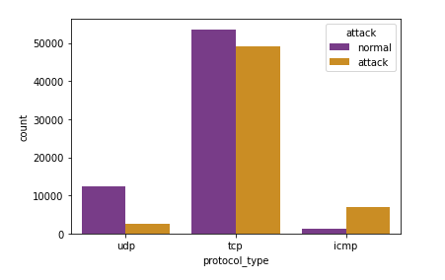
Figure 1. Distribution of malicious and non-malicious traffic with regards to protocol used
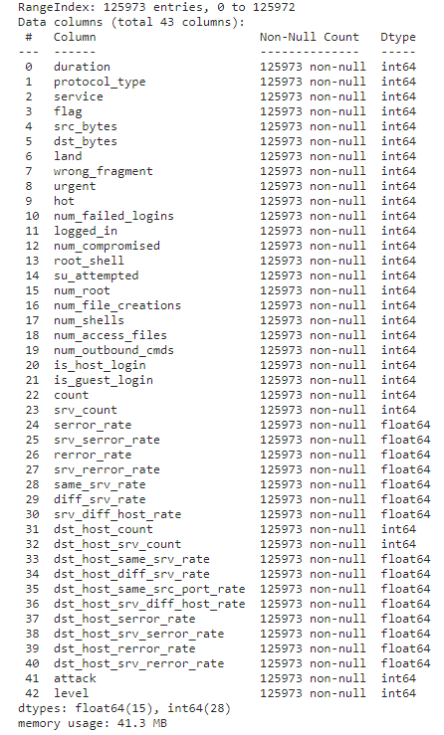
Figure 2. Dataset information
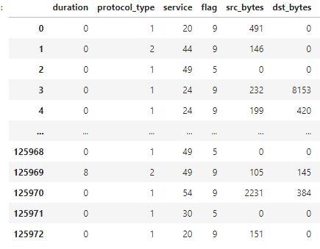
Figure 3. Example of values in dataset
The following data pre-processing was performed. The categorical values were converted to numerical values. The dataset was scaled using standard scaling, equation (1).
 | $$X^{'}= \frac{x-\overline{x}}{σ}$$ | (1)
Where x is the original feature vector, $\overline{x}$ is the mean of the feature vector, $σ$is standard deviation.
Lastly the labels were one-hot encoded for categorical classification.
For training we make use of a 70:30 split of training to test data.
As a baseline classifier, a simple deep network was implemented using tensorflow keras with two fully connected layers with 32 and 16 neurons, activation function is “relu”, batch normalisation layers and dropout layers to prevent overfitting (fig. 4). Final layer is a dense layer with “softmax” activation for categorical classification. Model metrics are “categorical_crossentropy” for loss function and “categorical_accuracy” for accuracy. The model was trained for 50 epochs on the dataset and achieved 99% accuracy, indicating possible overfitting (fig. 5). This classifier will be used to evaluate performance of the GAN-based classifier.
Second model is based on a generative adversarial network (GAN). These networks consist of a generator model and a classifier model. The generator uses gaussian distribution noise to generate fake information, equation (2).
 | $$P\left(x\right)=\frac{1}{σ\sqrt{2π}}e^{{-{(x-μ)}^{2}}/{2σ^{2}}}$$ | (2)
Where $μ$ is mean of the distribution, $σ$ is standard deviation.
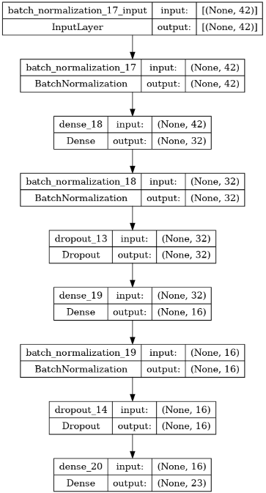
Figure 4. Baseline classifier DNN
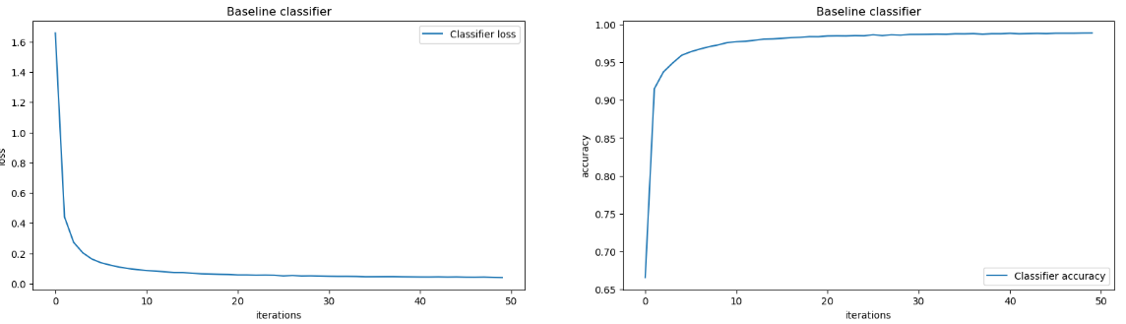
Figure 5. Baseline classifier metrics
The classifier model of GAN is used to classify generator output as real or fake. For this a DNN with sigmoid activation is used. The result of the classification is used to calculate generator loss and discriminator loss (fig. 6). This allows to train the generator to create more believable fake data.
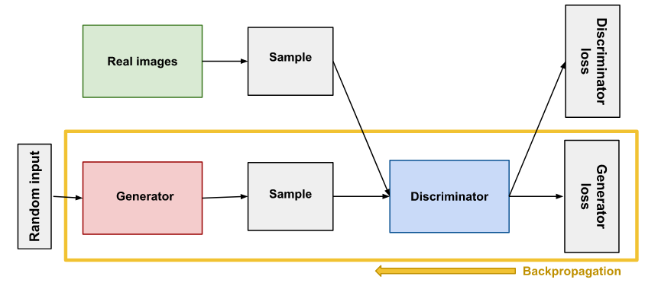
Figure 6. General GAN architecture
A subtype of GAN networks is a semi-supervised GAN. These are often used when trying to create a generator with little real samples available. In this case the discriminator predicts N+1 classes, with additional label being used for fake data classification. Of particular interest to this research is the efficiency of the categorical discriminator, not the generator model.
In our implementation, we use two discriminator models, one for real/fake categorisation and another for attack categorisation. Target of the research is the attack categorisation model. The models share weights to ensure correct categorisation for real/fake as well as attack class. We use two dense layers size 256 and “relu” activation, as well as batch normalisation and dropout layers. Output layers are “softmax” for categorical classification model and “sigmoid” for binary classification. Loss functions and metrics are “categorical_crossentropy”, “binary_crossentropy”, “categorical_accuracy”, “binary_accuracy” for categorical discriminator and binary discriminator respectfully (fig. 7) (fig. 8). Since all of our input data is labelled, we only use a small sample of labelled entries, between 100 and 500 samples, as initial input for categorical classifier model. For generator a model with three dense layers was used with 128, 256 and 512 nodes and “relu” activation. Additionally, batch normalisation and dropout layers were used. Output layer is dense layer with nodes equal to number of features and “tanh” activation (fig. 9). For model training 10 epochs were used. With final training categorical accuracy around 99% and binary accuracy around 78%. Final validation categorical accuracy around 89%. This indicates possible model overfitting (fig. 10-14).
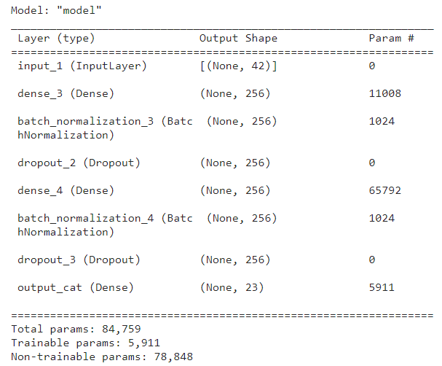
Figure 7. Categorical discriminator model
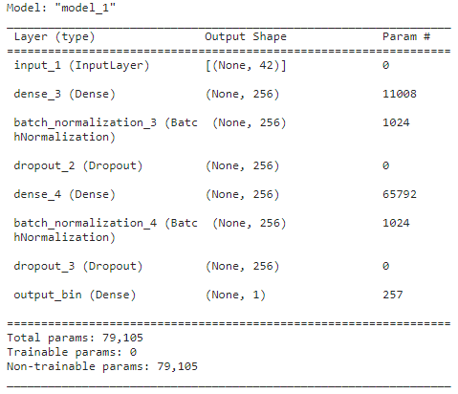
Figure 8. Binary discriminator model

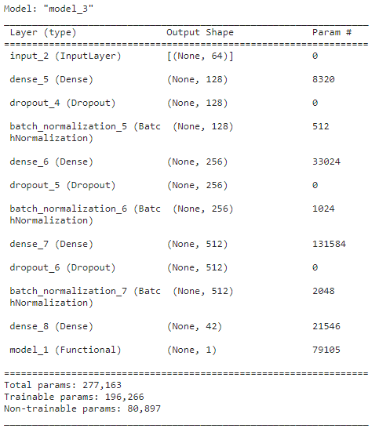
Figure 9. GAN model (generator and discriminator model)
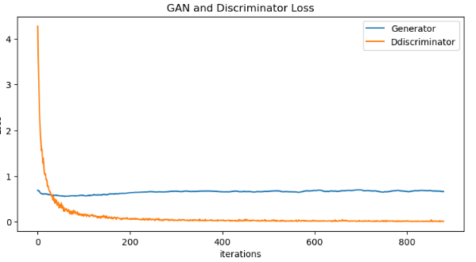
Figure 10. GAN and discriminator(categorical) losses
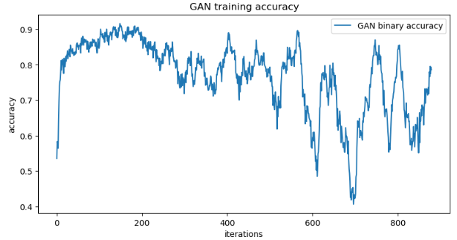
Figure 11. GAN training accuracy
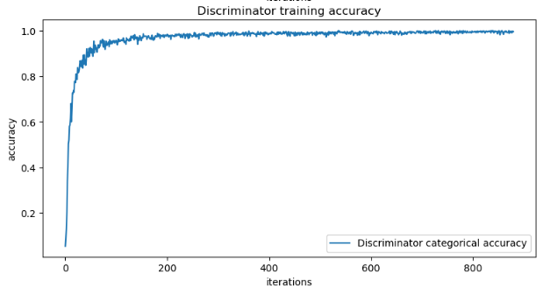
Figure 12. Discriminator training accuracy
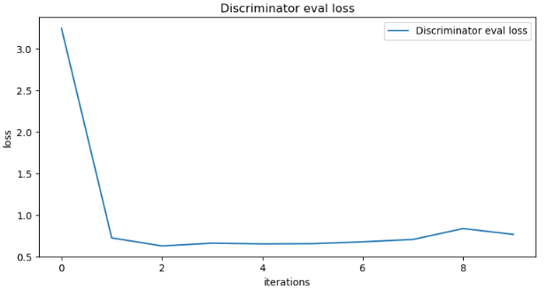
Figure 13. Discriminator validation data loss (every epoch)
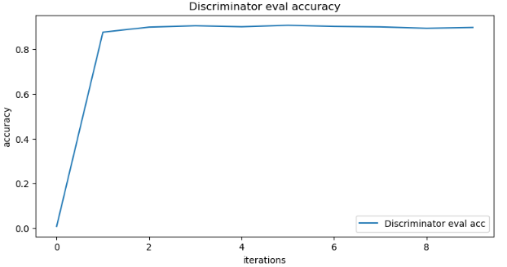
Figure 14. Discriminator validation data accuracy (every epoch)

Conclusions
This research proposes the use of semi-supervised GAN model to train a classifier network for categorising malicious network traffic with limited number of labelled entries. For comparison we also used a baseline classifier DNN with a full dataset. The baseline classifier managed to achieve a validation accuracy of 99%, whereas SGAN discriminator only achieved 88%. The SGAN discriminator shows signs of overfitting with training accuracy of 99%. While the results are subpar compared to a full dataset classifier, it is worth noting that SGAN model only received a small portion of the dataset labels, between 100 to 500 samples, in different tests, while still achieving a relatively high accuracy score. It should also be pointed out, that GAN networks generally have trouble generating entirely new information, instead it creates slight variations of existing data. As such it may not be able to be used to train a network to predict entirely unknown threats.
Overall, SGAN networks may not be an effective solution to training network attack classifiers, however, additional research may be conducted. In particular, the question of network hyperparameter tuning remains open, as it may allow us to prevent overfitting and improve model accuracy. Additionally, the research was conducted only on a single dataset, it is worth exploring additional datasets to further evaluate the proposed solution.
Literature List
- Chasaki D., Wu Q., Wolf T. Attacks on Network Infrastructure // 2011 Proceedings of 20th International Conference on Computer Communications and Networks (ICCCN) / HI, USA. Lahaina: IEEE, 2011. C.1-1. URL: https://ieeexplore.ieee.org/document/6005919
- Anderson R. Security Engineering: A Guide to Building Dependable Distributed Systems. Hoboken: Wiley Data and Cybersecurity, 2020. 1232 с. URL: https://ieeexplore.ieee.org/book/9820859
- Lan K., Hussain A., Dutta D. The Effect of Malicious Traffic on the Network // Proc. Passive and Active Measurement Wksp. (PAM). 2009. № 10. C.1-1 URL: https://www.researchgate.net/publication/228611227_The_Effect_of_Malicious_Traffic_on_the_Network
- John W., Olovsson T. Detection of malicious traffic on back-bone links via packet header analysis // Campus-Wide Information Systems. 2008. № 25 (5). C.342-358 URL: https://www.emerald.com/insight/content/doi/10.1108/10650740810921484/full/html
- Network Traffic Analysis and Intrusion Detection Using Packet Sniffer / M. Qadeer та ін. // 2010 Second International Conference on Communication Software and Networks. Singapore, 2010. C.313-317. URL: https://ieeexplore.ieee.org/document/5437681
- Wang W., Gombault S., Guyet T. Towards Fast Detecting Intrusions: Using Key Attributes of Network Traffic // 2008 The Third International Conference on Internet Monitoring and Protection. Bucharest, Romania, 2008. C.86-91. URL: https://ieeexplore.ieee.org/document/4561331
- Network Intrusion Detection System: A Machine Learning Approach’ / M. Panda та ін. // Intelligent Decision Technologies (IDT) Journal, IOS Press. 2011. № 4 (5). C.347-356 URL: https://content.iospress.com/articles/intelligent-decision-technologies/idt00117
- Augustus O. Semi-supervised learning with generative adversarial networks // arXiv 1606.01583. 2016. № 0. C.1-3 URL: https://arxiv.org/abs/1606.01583
- Pasupa, K., Tungjitnob, S., & Vatathanavaro, S. (2020). Semi-supervised learning with deep convolutional generative adversarial networks for canine red blood cells morphology classification. Multimedia Tools and Applications, 1, 1-1. Retrieved from https://doi.org/10.1007/s11042-020-08767-z

UDC 004.___
Method for malicious network traffic categorisation /Dremov A.K., Volokyta A. M. // Interdepartmental scientific technical journal «Adaptive systems of automatic control».
Object of research is a network attack classifier based on machine learning algorithms. This article reviews the basic principles of using ML for network attack classification. One of the main drawbacks of this approach is the large amount of input data required.
The aim of this research is to build a ML-based classifier, that can be trained with a limited amount of data. To achieve this, a SGAN model is proposed in order to train the classifier. The SGAN architecture allows to train the classifier model with a small number of examples.
Keywords: cybersecurity, network security, malicious traffic identification, machine learning, generational adversarial networks, semi-supervised learning.
Ref. 9, fig. 14, tabl. 0

УДК 004.___
Метод категоризації шкідливого мережевого трафіку /Дремов А. К., Волокита А. М. // Міжвідомчий науково технічний журнал «Адаптивні системи автоматичного управління».
Об'єктом дослідження є класифікатор мережевих атак на основі алгоритмів машинного навчання. У статті розглядаються основні принципи використання машинного навчання для класифікації мережевих атак. Одним з основних недоліків цього підходу є велика кількість необхідних вхідних даних.
Метою цього дослідження є побудова класифікатора на основі методів машинного навчання, який можна навчити на обмеженій кількості даних. Для досягнення цієї мети пропонується використовувати модель SGAN для навчання класифікатора. Архітектура SGAN дозволяє навчати модель класифікатора на невеликій кількості прикладів.
Ключові слова: кібербезпека, мережева безпека, ідентифікація зловмисного трафіку, машинне навчання, генеративні змагальні мережі, напівкероване навчання.
Бібл. 9, іл. 14, табл.. 0

Authors
Volokyta Artem – Ph. D., Associate Professor, Department of Computer Engineering NTUU “KPI”.
Scientific interests:
Real time systems, information security, distributed computations
Dremov Artem – student of the Department of Computer Engineering NTUU “KPI”.
Scientific interests:
Real time systems, cybersecurity, machine learning.
Про авторів
Волокита Артем – к. т. н.., доцент кафедри обчислювальної техніки НТУУ “КПІ”.
Наукові інтереси:
Системи реального часу, захист інформації, розподілені обчислення
Дремов Артем – студент кафедри обчислювальної техніки НТУУ “КПІ”.
Наукові інтереси:
Системи реального часу, кібербезпека, машинне навчання.

Контактний телефон: 050 287 19 87.
e-mail: a.k.dremov@gmail.com

